Link for Registration
This is to register your Organisation on the UN Partner Portal. Please note that this Portal is used by over 10 UN Agencies

https://www.unpartnerportal.org/login

- click ‘Sign up now’ at the bottom
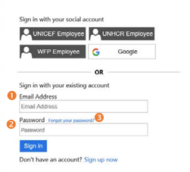
- Enter in your email address
- Click ‘Send verification code’ – which is sent to the above email address
- Enter in the remaining fields
  - For Display Name – can enter in either your organisation or your name
- Enter your email address and password you have just created to now sign in

UN Partner Portal Registration
The Partner is required to register on the UN Partner Portal prior to commencing an agreement with UNICEF
- Annex 2 – Guidelines for registration

