ePD PORTAL –THE FORMULATION AND APPROVAL OF A PROGRAMME DOCUMENT

https://etools.zendesk.com/hc/en-us/sections/8610374197780-ePD
UNICEF has provided video resources for each component. Please reference these videos for comprehensive guidance.
The below is adapted guidance noting the key Steps

INPUTTING CSO PARTNER DETAILS IN e-Tools

You can only initiate a new Programme Document in e-Tools if the CSO Partner Vendor has been created in Vision. Please liaise with the HACT focal point for the Registration.
Refer to https://unicefpartners.org/journey/ - and click on ‘Registration’ on the left – to view the 3 Components and steps

INITIATION OF PROGRAMME DOCUMENT IN e-PD

STEP 1
UNICEF
The Unicef Programme Focal Point will initiate the new Progamme Document in ePD.
It is important to note that the Partner Contact Details need to be first entered in the Partner module – which then allows you to select the Partner Name in the ePD when the Programme Document is initiated.
Please also note that you can enter multiple Partner Contacts

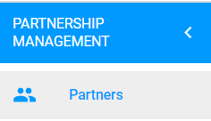

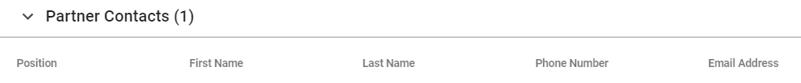

When Initiating a Partner Document – you select from the drop-down box in the ‘Document Partner Focal Point’ field. Names will only appear if they have first been entered in the ‘Partner’ module in e-Tools.

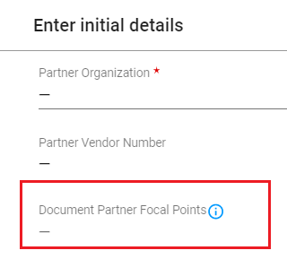

PARTNER REGISTRATION AND LOGIN to ePD

The Partner will register for the ePD portal as follows
https://etools.unicef.org

To note that this is a separate login process to the following
- UNICEF Reporting Portal (for submitting Progress Reports): https://www.partnerreportingportal.org/landing/):

UNICEF will use their existing e-Tools login credentials (also https://etools.unicef.org)

ROLES OF UNICEF AND PARTNER
For UNICEF, there are the following roles
- Programme Focal Point – who will liaise with the Partner to complete the Programme Document
- Budget Owner – has the authority to submit the Programme Document for review to the Programme Review Committee

For the Partner:
- Programme Focal Point – who will liaise with UNICEF to complete the Programme Document

SWITCHING BETWEEN UNICEF AND PARTNER
This following will appear at the top of the screen once the Programme Document has been initiated by UNICEF. The portal allows the Programme Document to be transferred between UNICEF and the Partner – so that each party can input data

UNICEF view


Partner View



COMMENTS TAB

At the top of the screen, the ‘Comments’ can be activated – this allows both UNICEF and the Partner to input comments

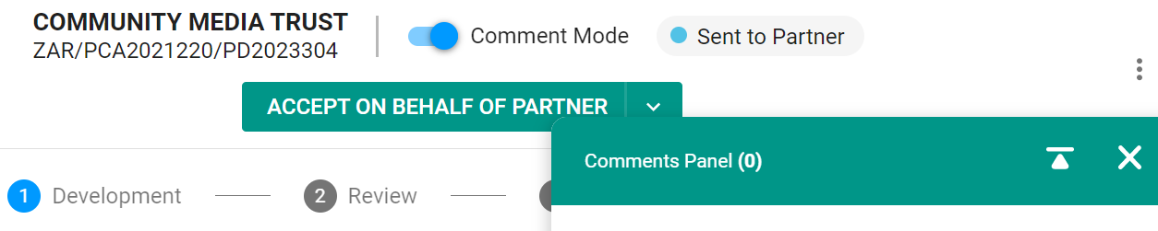

- Turn the Comments Toggle ‘On’
- Minimise the comments box
- A green outline now appears around each Category area
- Click the Edit button and enter relevant comments
- The green outline turns to Red – to indicate that there is a comment that requires a response
- Both UNICEF and the Partner can click ‘Resolved’ once the other party has responded

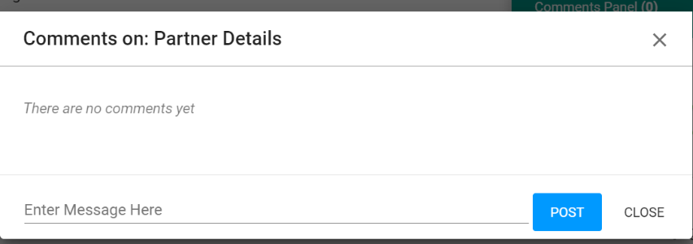

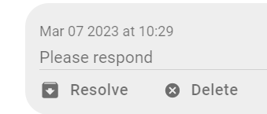

STEPS FOR INPUTTING THE DATA INTO THE ePD

It is strongly recommended that a draft is first done off-line for the following components:
- Programme Document Strategy
- Results Matrix
- Detailed Budget

This will allow both UNICEF and the Partner to collaborate and provide feedback. This also allows for the Results Matrix to be reviewed by the UNICEF M&E Specialist and the Budget to be reviewed by the Quality Assurance Specialist – with recommended changes incorporated off-line.

Please refer to https://unicefpartners.org/journey/ and click on ‘Formulation of Programme Document’ on the left to access the relevant Templates

Once the Programme Document, Results Matrix and Detailed Budget have been internally finalized and the data is ready to be inputted in ePD:

STEP 1
UNICEF
- Under the Workplan tab, add the 'CP Output' (Country Programme Output)

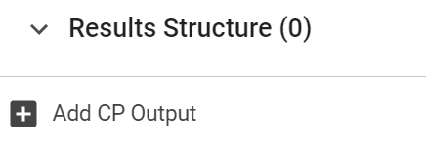

STEP 2
UNICEF
- The categories under the Strategy tab need to be completed
  - This provides the programmatic rationale

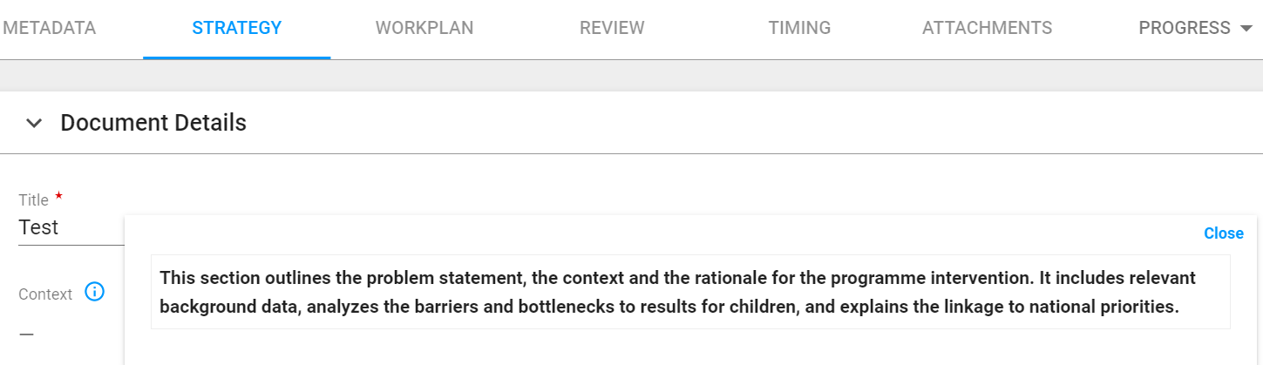

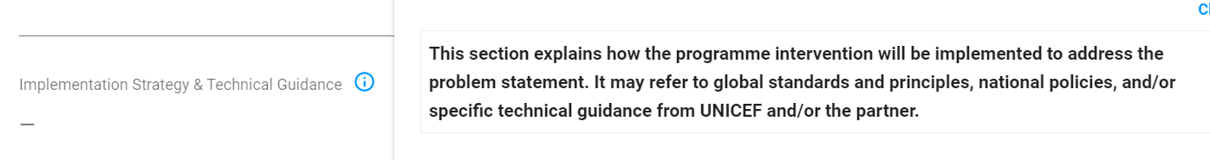

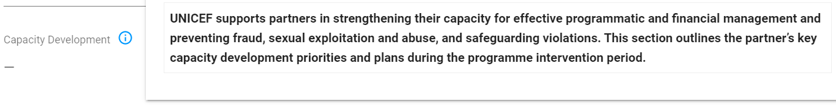

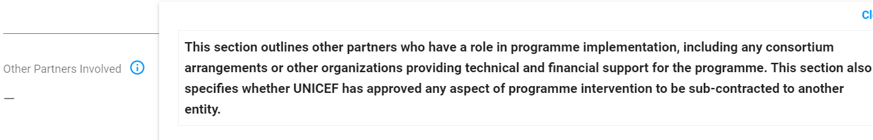





STEP 4
UNICEF
- Under the Workplan tab, the Programme Document Outputs need to be entered
  - Please refer to Annex xx for guidance on the formulation of an Output Result
  - Per the guidance, please note that each Output result needs to include ...

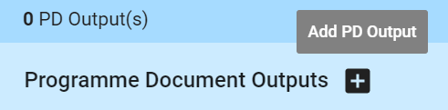

STEP 5
UNICEF
- The Activities and Indicators for each Programme Output need to be entered
  - Please refer to Annex xx for guidance on the formulation of Indicators

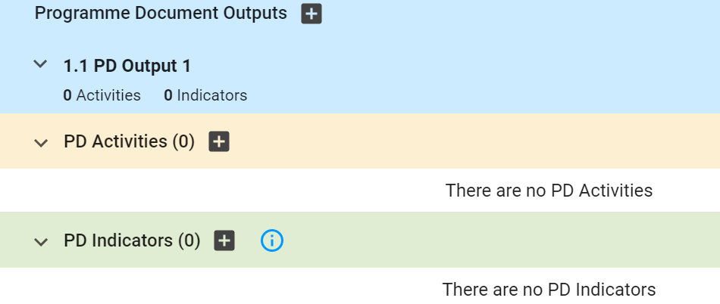

STEP 6
UNICEF
- Under each Activity, the budget is entered
- Please note that the detailed budget will already have been formulated per the Excel Template – therefore only need to enter at the Activity level total

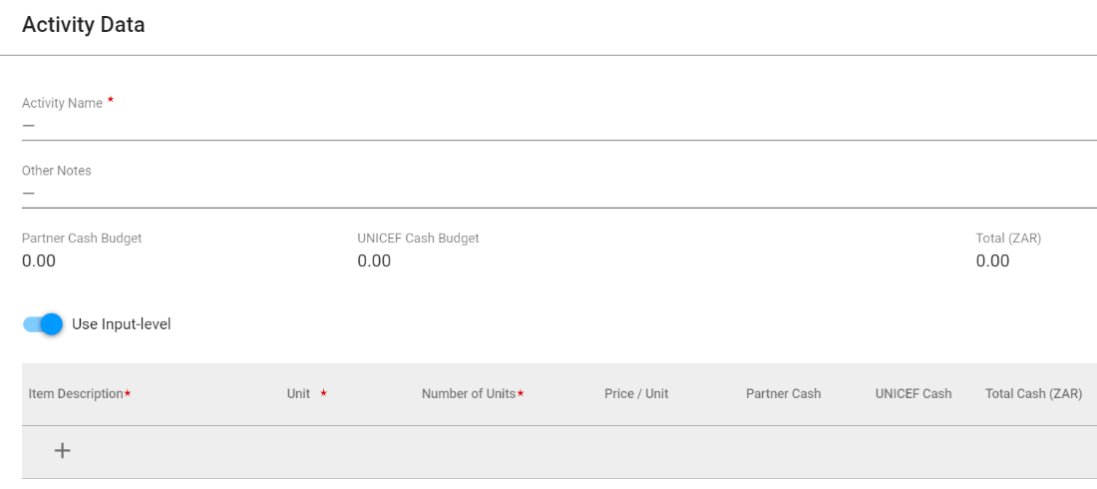

STEP 7
UNICEF
- enter the relevant Budget line items under the following 'Effective and Efficient' Programme Management'
- For each please ensure that you active the 'Use Input-level' for each category as relevant

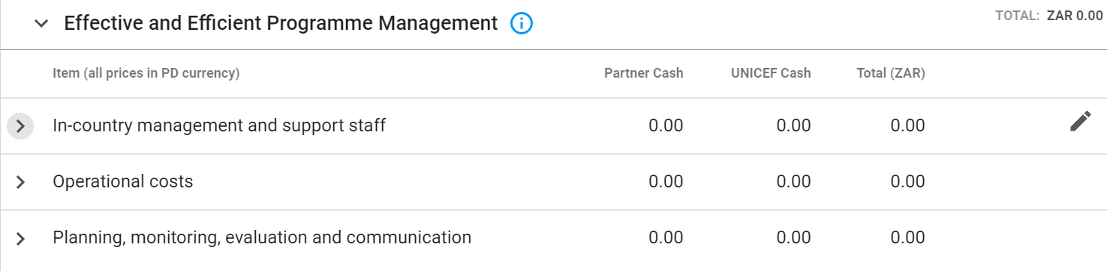

STEP 8
UNICEF
- Enter any non-financial contribution as relevant

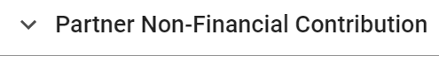

STEP 9
UNICEF
- Upload any relevant attachments under the Attachments tab

STEP 10
UNICEF
- Once finished all the above - click 'Send to Partner'

STEP 11
Partner:

The Programme Document has now been assigned to the Partner.
It is the Partner’s responsibility to review in detail and advise UNICEF is any further changes need to be made.

Once the Partner is satisfied that correct – clicks ‘Accept as Final’



STEP 12
UNICEF

For UNICEF, only the ‘Budget Owner’ can ‘Accept as Final’ – the relevant Section Chief is normally assigned this role

Budget Owner clicks ‘Accept as Final’

To note that an error msg will appear for fields still be completed

STEP 13
UNICEF BUDGET OWNER
Once ‘Accepted as Final’ – click ‘Send for Review’

To note that if click ‘Unlock’ – this allows you to make changes to the Workplan, send to the Partner etc



Choose either PRC or Non-PRC
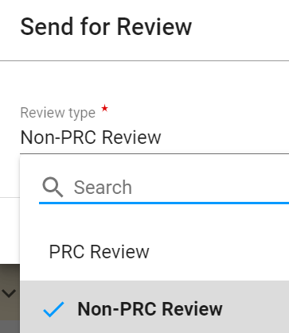

PRC SECRETARY REVIEW

Only the PRC Secretary can assign for Final Approval

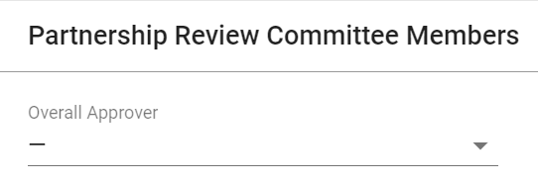

FINAL APPROVAL
The UNICEF Approver will provide final approval

