Reporting Portal (https://www.partnerreportingportal.org/landing/):
- Follow the steps outlined below in order to sign up and log in

Please note that each Partner can only sign in using the email address designated as the ‘Authorising Officer’ for your Organisation.

- Click on Sign in

- Click on “Sign up now”

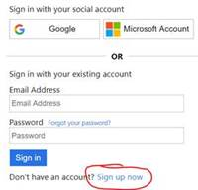

- Follow the prompts to sign up
  - you will be sent a verification code to the designated email address - and then you will need to create a password
- Once you have signed up, please login again

